**WAP to Print Elements Using Loops**

**While Wend**

**Private Sub Command1_Click()**

**Dim a As Integer**

**a = 1**

**While a <= 5**

**Print "Sanjeev"**

**a = a + 1**

**Wend**

**End Sub**

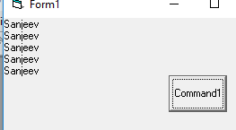

**Do While Loop**

**Private Sub Command1_Click()**

**Dim a As Integer**

**a = 1**

**Do While a <= 5**

**Print a**

**a = a + 1**

**Loop**

**End Sub**

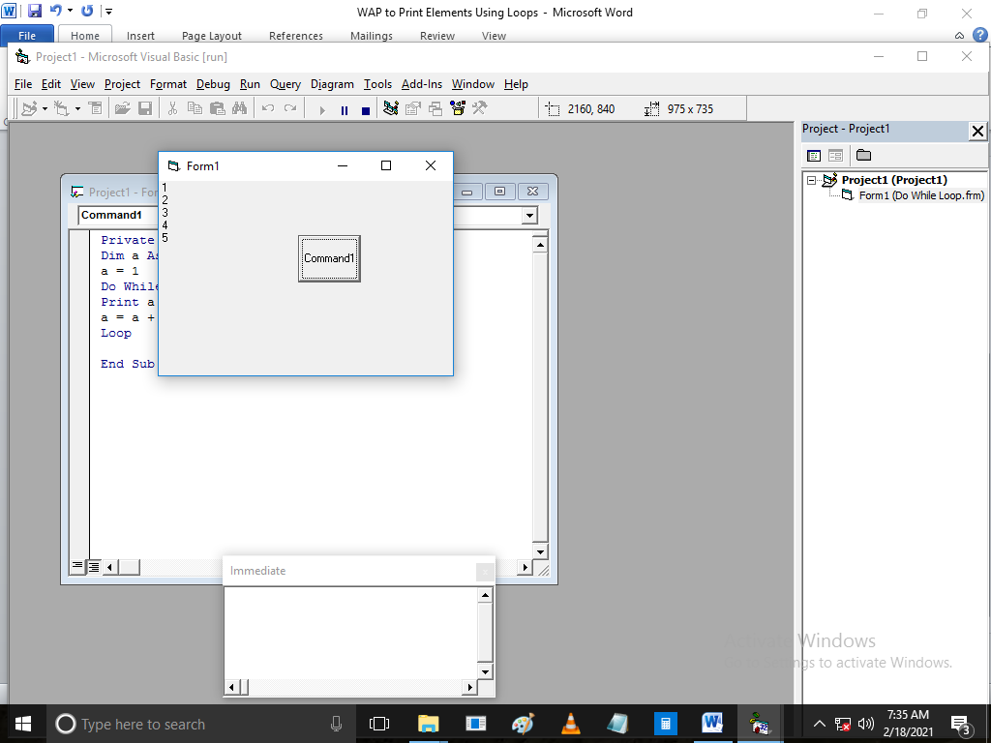

**For Loop**

**Private Sub Command1_Click()**

**Dim a As Integer**

**For a = 0 To 9**

**Print a**

**Next**

**End Sub**

